Date 9/11 , September ,11 2025
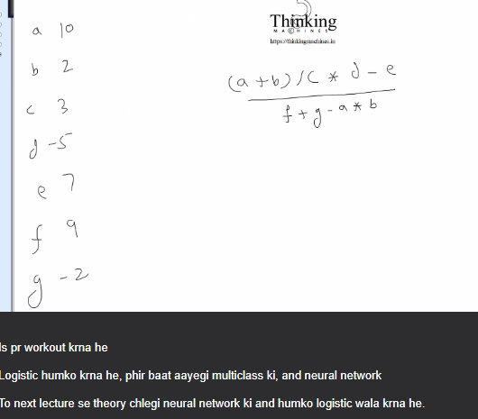
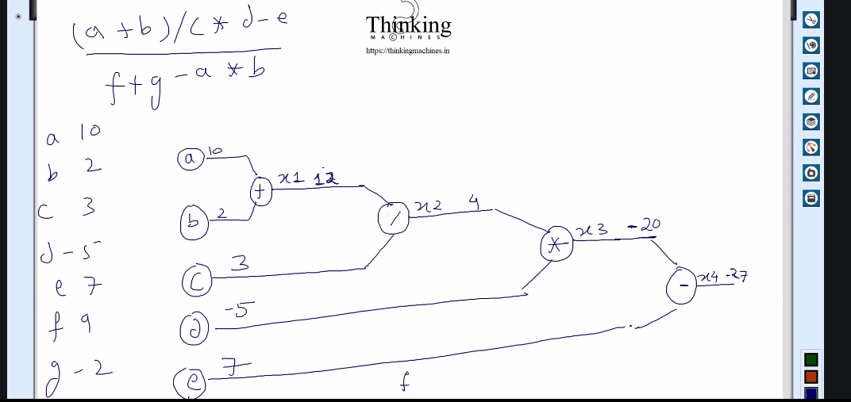

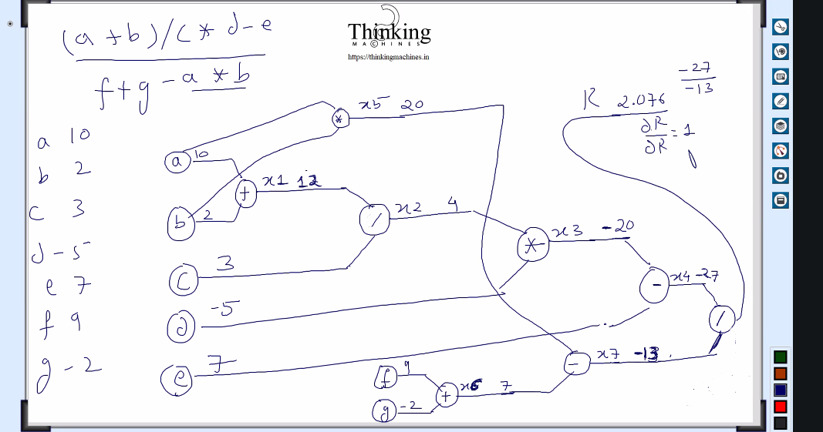

DR is locall gradient dr/dr=1 aaya back propagate krege and below wala nikalega.
Ab dr/dx4 and dr/dx7
Backpropagate means result change wrt x4 and r change wrt d7
X4 k case me x7 ko constant and x4 ko variable , ye isko local bolte he
Final jb a,b,c,d ka niklega means main variables ka to usko global bolege
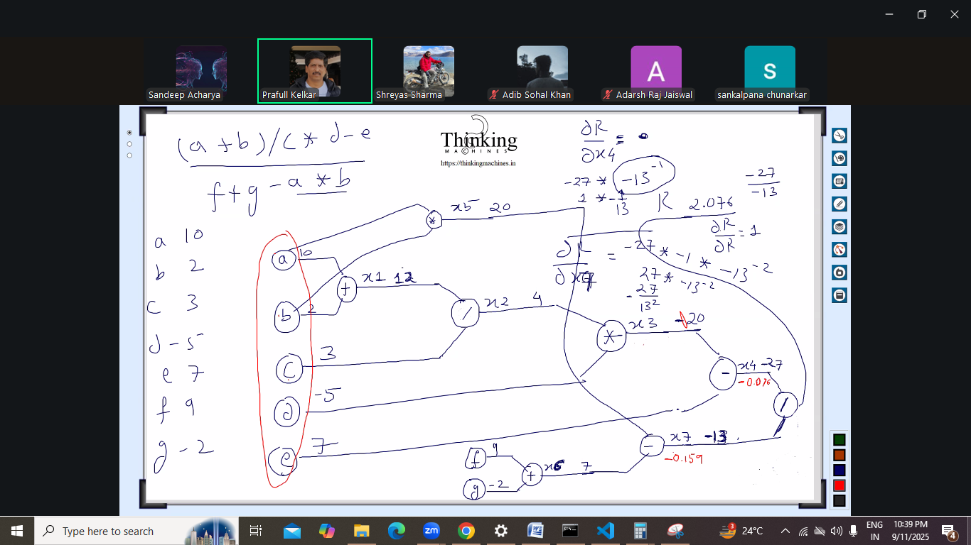

Backpropagate kr k parameters update krna, aage ese scenario aayege jb solution nahi milega, kyuki tensorflow use krte he log.
Bni bnayi lib use kr rhe he to ye sb nikalne ki jarurat nahi pdegi
Final dr/da,dr/db,dr/dc ……………ye global rahege
Lib bnanae walo ne ye sb rules bnaye hoge and har gate k liye kuch na kuch bnaya hoga
Hum input matrix lege he derivative ki theory apply kr k model update and again iterate.
To neural network k liye jaye to kya benefit rahega.
Jb humara kaam abhi wale tarike se , classification and linearregression ka ho raha he to why go for neural network.’
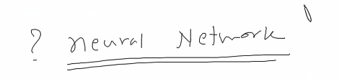
Neural network me backpropagation ki jarurat padegi.

Date: 9/13 september
Ek system h usme complexity increase kr rahe he , har level pr parameter increase kr rahe he and unimagable he but finally model train ho jayega, unthinkable kuch bhi hoga

Kitne layer and kitne neuron hoge ye bhi fix nahi he.
Necessary infra likhne ka code, saamne wala number of layer and neurons decide kre
Kisi ne esa soch rakha he humko maan na pdega.
Operation fix hoga but use of function saamne wala decide krega,
Neuron ki jagah node bhi bol skte he

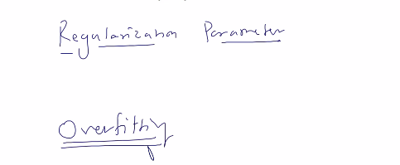

Regularization parameter to avoid overfiting.
Ye naye terms he.

Neuron and dendroits: is se pta chl jayega ki neuron kyu bolte he
Abhi humara interese infra ready krne me he.

Jitne nodes bnege
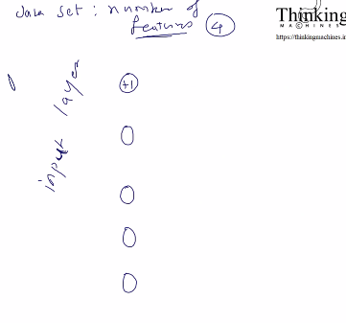
Data set me 4 feature hoge and ek bias included vo + wala
Ab iske baad hidden layers and end me output layer
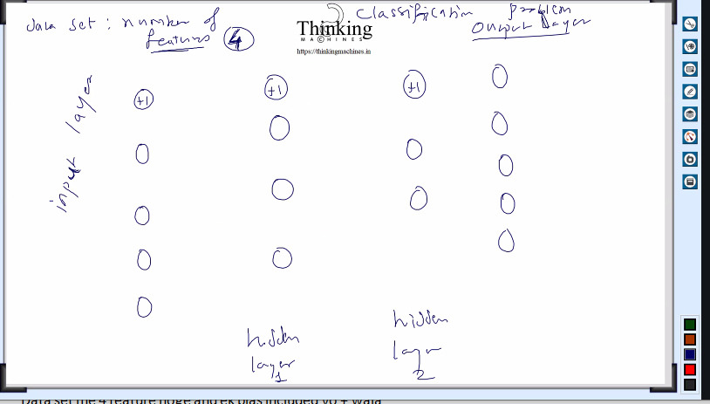

Output layer pr 5 node he to data set me 5 targeted claases hogi, if we take example of classification.
Classes means Classification me classes of category like , dog cat , animal ki classes

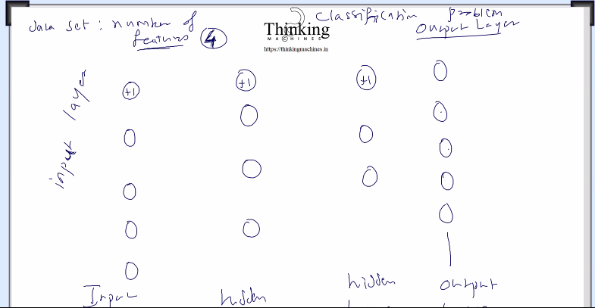
Number of hidden layers bdlegi but input layer and output layer fix rahegi.
Hidden layer ko activation layer bhi bolte he.

Ab nodes me connections:
Bias wale k sath koi connection line nahi jayegi kyuki usme caluculate kr k kuch nahi dalna he
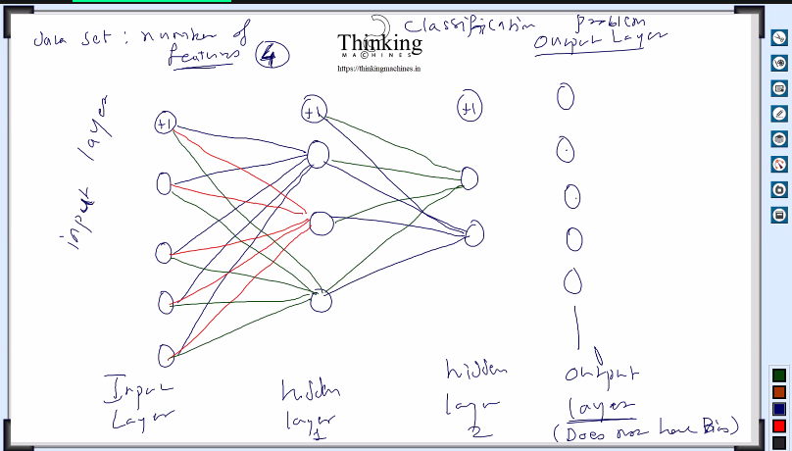
Ese hi aaage layer connect krna
Bias wali se jaa skti he line pr usme aa nahi skti, means usme koi calculation nahi ayega
Har line pr ek number hoga vo humara theta hoga
And ese bahut saare theta k set hoge.
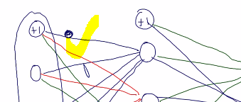

Theta or nodes ko lekr operation perform krege and usko second layer me daalega
Esa kr k next layer ka data mila, same next layer ka data and theta me operation perform krege and us se jo result milega vo next layer ka data hoga. Isko forward propagation bolte he
Isko
e.g. first layer ka data and us se jane walli line k theta se jo operation hua usko vo line jaha khtm hogi
usme result store krege , result kese store krege vo aage dekhege.
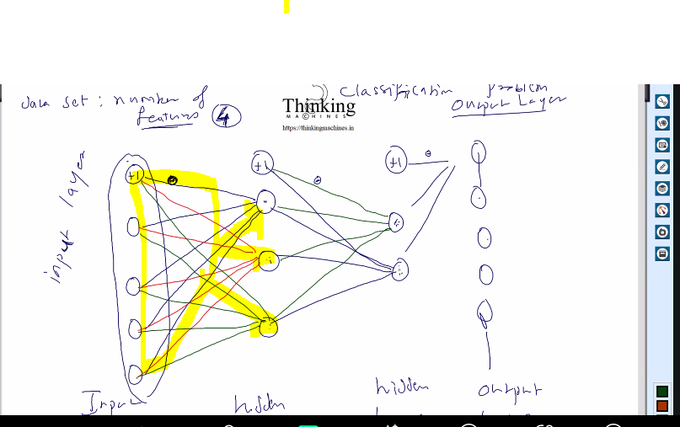
Is process ko forward propagation bolte he.
Ab next process: cost or loss compute krne ki.
Phir backward propagation me jinte bhi theta he unko update krege backward , and har layer k bich me theta k set ko update krne ka kaam.
Back propogation me saare theta update hoge ,
Vo computational graph bna k .
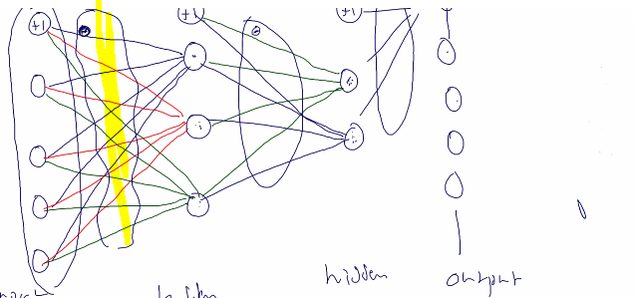

Abhi dataset kesa hoga and poperations kya hoga:
Maan lo 100 row he and 1000 iteration he
100 me phla row tha k forward propagation then backword apply
Phir alga low and forward backward
….till nth row
Saara data khtm hone k baad next iteration.
Saare theta 100 baar update hoge kyuki 100 rows he.
Ek baar me ek row.

Dataset k numer of columns = number of nodes in layer or ek bias wala bhi add kr skte he.

Abhi next:
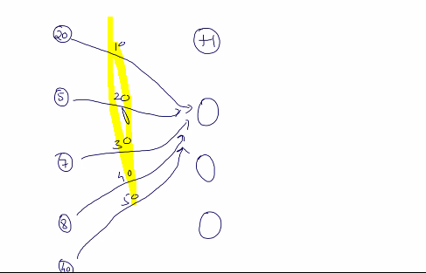
Highlighted wala theta he. And 5,7,8 ,40 data set he.
Kayde se data to 1 and 0 k bich hona chahiye pr abhi skihne k liye 10 20 30 40 liye.
Abhi first node ko ese update kregr
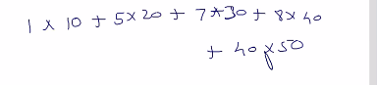 +1 means bias wala node.

Dusri node k liye theta and uska calculation:
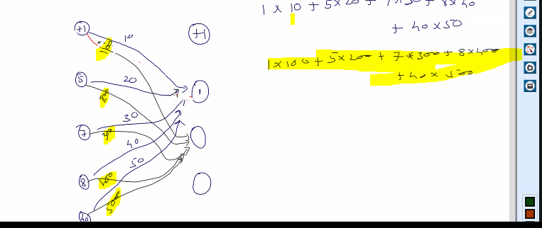
Similarly fir dusri node k liyetheta:
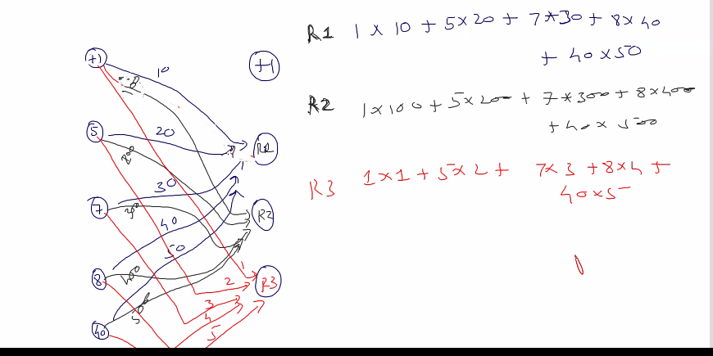

Ese kr k next layer k nodes ka data generate hoga.
Ab agar mene
Node maintain krne kl iye vector
And thetas maintain krne k liye 3*5 ka matrix
Ab m*v krege to r1,r2,r3 ka vector bn jayega.
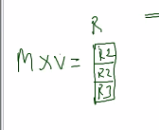
Matrix me thertas rkh dege like 0 row pr

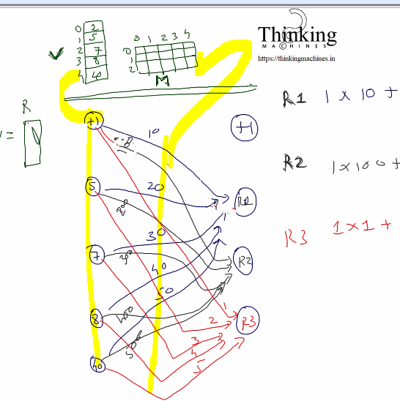

Ab har layer k liye matrixs
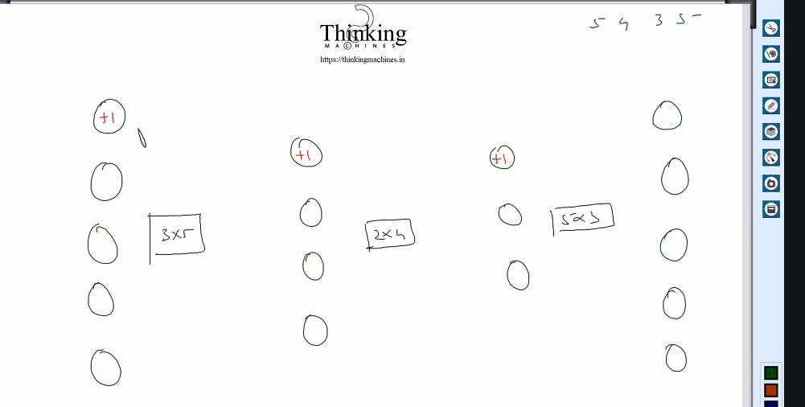

Ab cost layer and theta k bich k operation ko ek function ko dege like sigmoid and vo jo dega vo next lyer me dalege
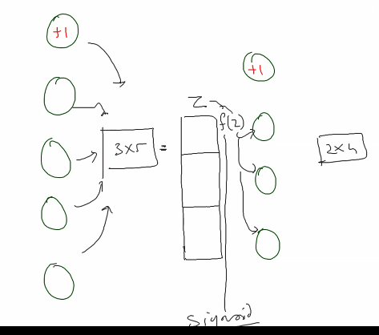
Z me dala , Z function ko diya and function ne jo diya usko next layer me dala
Ye hua forward propogation ka structure
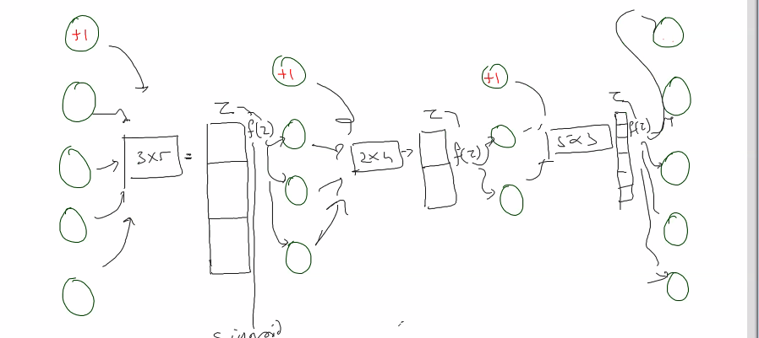

Ab dataset file me 100rows and 5 columns unme se 4 features +1 target [vo y wala]
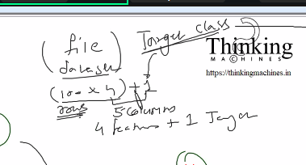
Final me 5 possible target classes hogi
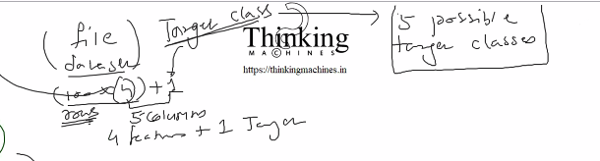

Maan lo first row ki target class 3 he to target matrix me phla row ese dikhega
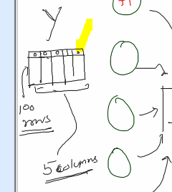

And X esa bnega
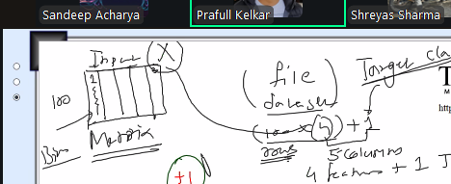

Phle ouput Y k liye vector lete the , but ab Y bhi as a matrix lena hoga, kyuki classification wala example le rahe h.
To jese input X me 100 rows he to 4 feature +1 bias he to Y me bhi 100 rows and 5 columns hoga
Y k Har row me saare columns me 0 hoge and only ek column me value hogi ,
Konse column me value hogi vo target class k upar depend krega.
Suppose X matrix first ki row ki target value 3 aayi and uska target class 5 he
To Y matrix k first row me 5th column me vo value rkhi jayegi and baki saare columns me 0 rakha jayega.
5 target class iliye kyki output layer me 5 nodes.
Doubt agar 6 target class hoti to 6 columns bnte, no. of column in Y will be depends on number of target classes
Linear regession k case me ek hi column the kyuki vaha classification wali baat nahi kri thi.
So final: number of columns in Y will be number of target class.
How to decide target class? Doubt for next session.
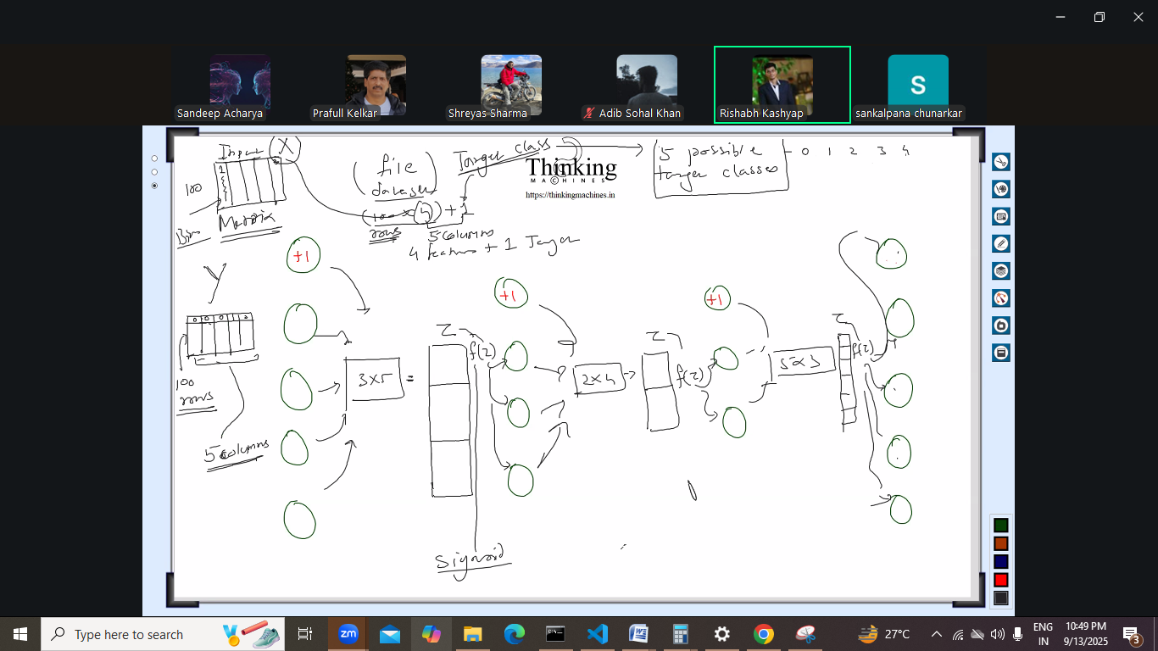

Next back propagation and computational graph.

Date: 9/18 , September 18 2025
back propagation and computational graph.
Logistic k case me issue log(0) ,
To is case me ek epsilon add kre, vesr to 0 nahi aayega but float adjustment me 0 ho skta he
To iske liye epsilon ki theory ek small value add krege.

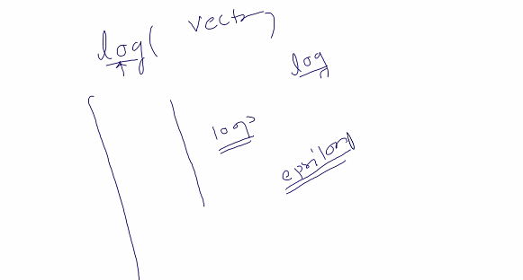

Dataset me 0 se 1 k bich me lena he and scaling apply krna he
Roud of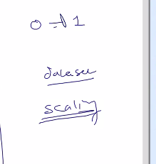
Data , dataset ko tool se scale kr k.
Alag alag machine me issue me alag alag issue aa skta he coz
Neural network ,
Implemetation is nothing agar thodi si mehnat necessary math involved pr kr le to.
Or sb copy ka kkhel he, is batch me intuition ki theory avoid k ki kese cost function ka derivative ye krega ki next value kese improve kiya jaaye
Esa example jo result accha produce kre.
Logistic humko krna he.
Ab neural network k piche ka math related to back propogation
Humare paas input he us se z bnega kuch operation perform kr k
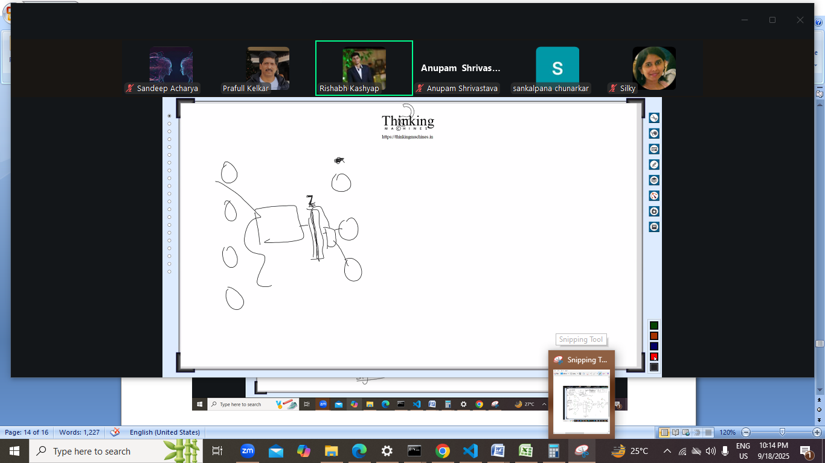
Z compute krne k liye weight ka use kiya that is theta.
Vo z ek function ko diya
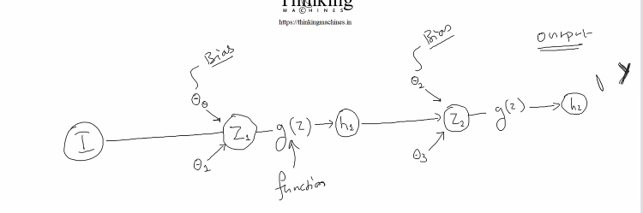

Output aayega and actual y rahega , ab compute krna he panelty.
Isko backpropogate krne k liye
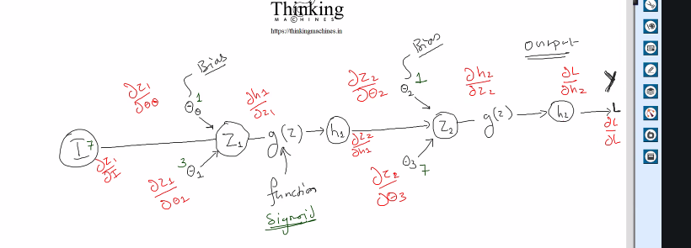
Ye one training example ki baat ho rahi he.
Chaho to L= h2-y le skte he, binary cross entropy ki baat kr rahe he mse ki baat ho rahi he
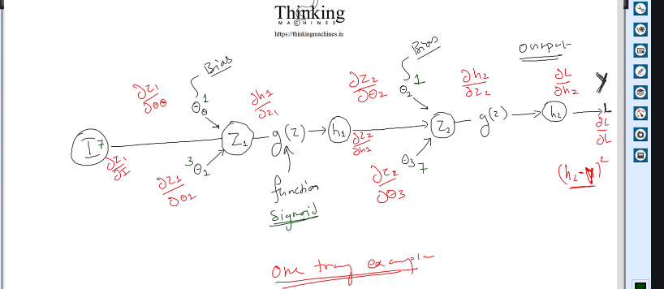

Graphic card ho to ek interesting aspect parallel wala.
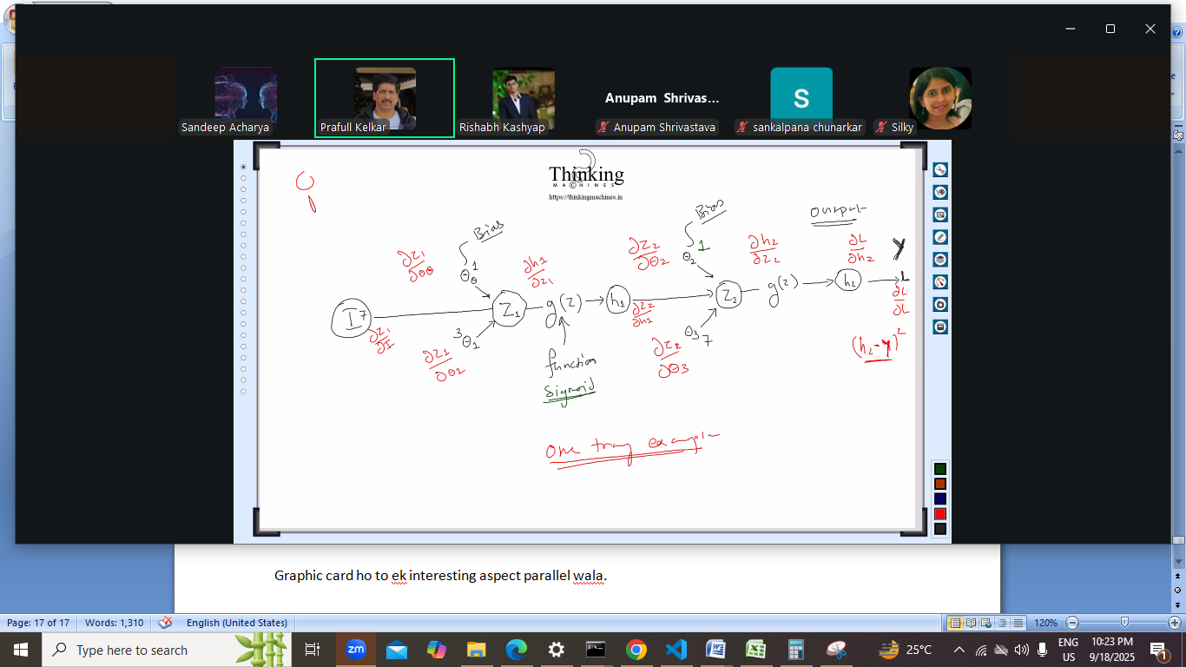
Isko implement krna he next session , and kr k dikhana he
Ek single input pr bias wali baat bhi he isme
Pyton k code se csv ko scale krwa lo
Excel me csv file bna k formula de do , better he ki pyton k use kr lo.
Next session Tuesday 23 september.

23 september 2025 9/23/2025
Aaj jo kr rahe he usko paper pr krna pdega
Suppose we have one training example. Ek pr kaam krege and vo multiple k liye ho jayega
Note: base index 1 lekr chlege, 0 nahi.
We have only x and y we are not talking about x[i] and y[i]
50 baar kra sir ne tab ye formula likh paa rah he
Sir ne 50 baar kiya kyuki unke paas galti krne ka moka nahi he
Unko teach krna he bina galti ke. To sir ye cost function likh paaye
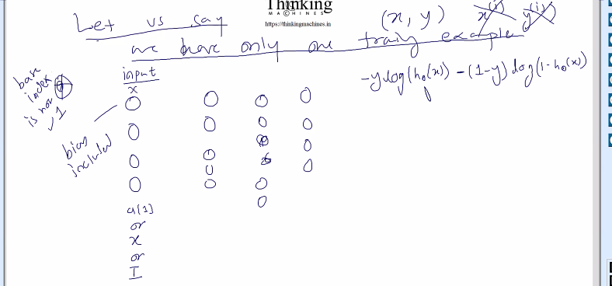

Abhi 4 output nodes he and for every node we have to compute
Ye –ylog…. Is formula for loss denoted by L
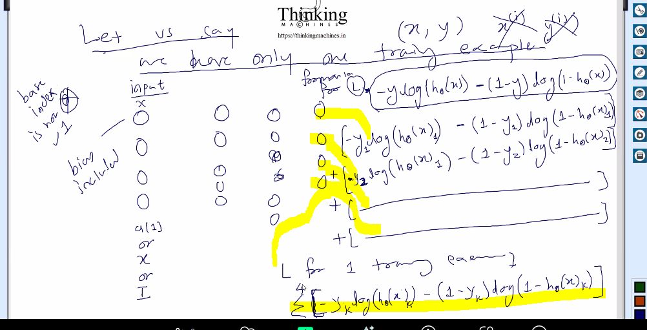
Yaha pr layer ko a[i] ya X ya I se denote kr rahe he.
Ye hua for 1 training example. For each node. In output layerand input layer
For all training examples do summation of y=1 to i
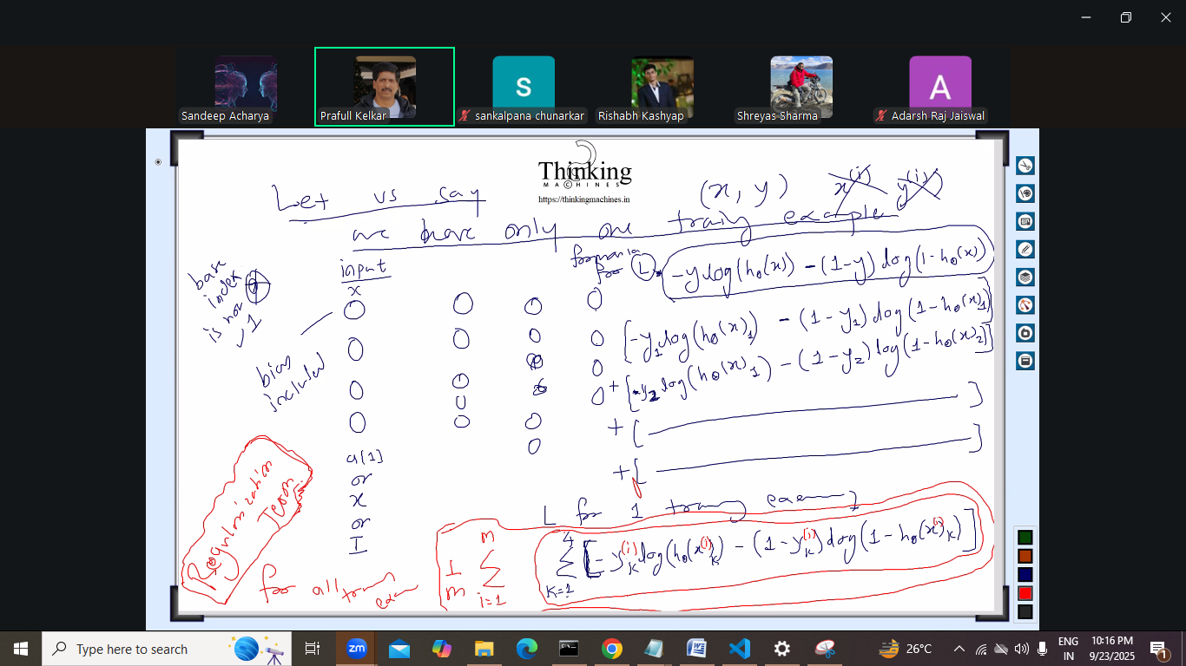
The above is very imp
Now move to back propagation:

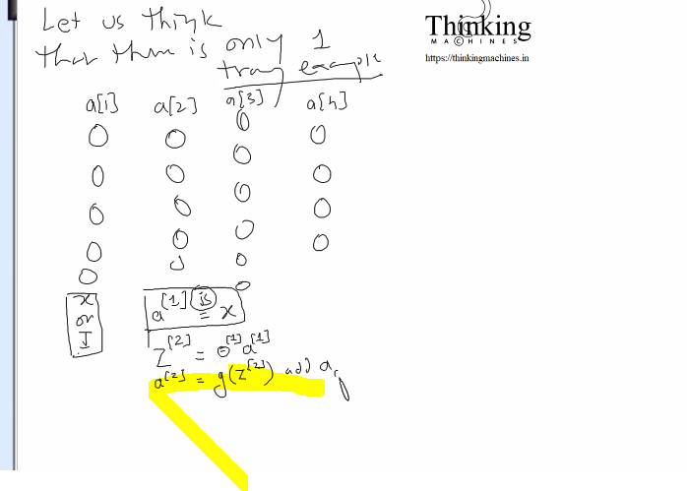
Yaha pr g of z[2] jo likha he isme bias nahi hoga to bias add krna pdega.
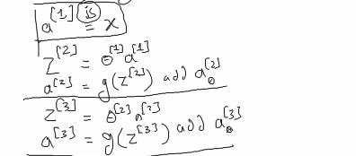
Add a0[3] mans 3rd layer jo a se denoted he usme 0 pr ek node add karo for bias
Output layer me bias add nahi krna he.

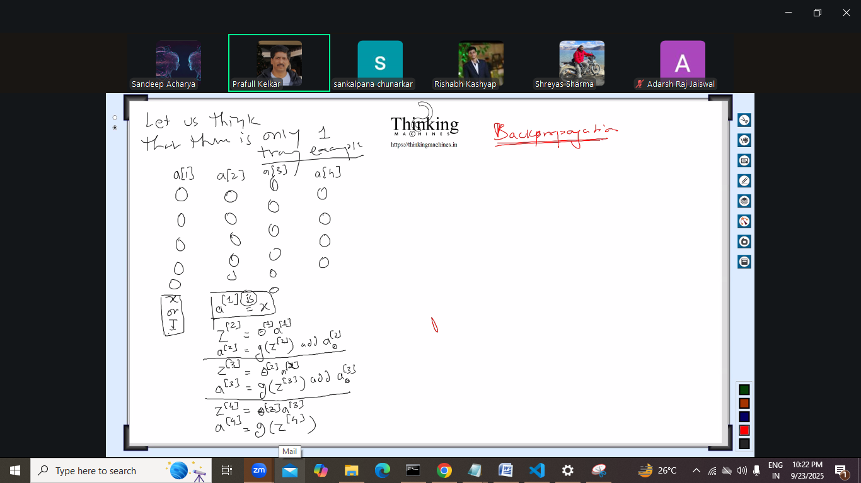
Ye krte krte losss compute krne ki baat aayegi.
What we are wishing: ki output changed aaye, the a[j] denoting a layer would be different next time.
Ab ek notation introduce hoga: lowercase delta
Isme lowecasedelta me error of a node hoga.
Error compute krte he and har node k liye binary cross entropy apply kr k jo aayega vo eerror of a node hoga.
Or say error of node j in layer L. => aj[l]
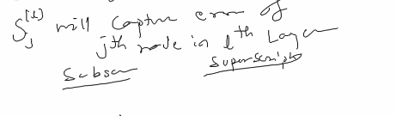
lowercase delta with superscript as l and subscript as j , represent jth node of lth layer
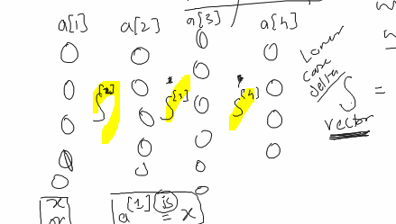
Delta of 1 nahi hoga coz 1st layer to input he usme thodi change aayega
To ese delta 2,3,4 bnaege for 2nd 3rd and 4th layer
Q:
DL/da4 = iski kahani alag he isme g wali baat nahi aayegi , piche wali layers me g ki baat aayegi.
Last layer k liye tarika different hoga.
Output layer me jb delta ki value compute krni hogi tb tarika alag hoga and uski previous layers k liye tarika alag hoga, piche wali saari layers ka tarika common hoga.
Only output layer wali ka tarkia change hoga.

Now for each output node we will compute delta. [delta is to capture the error part to error nahi delta hi bolege.]
As per our diagram output layer is 4 and number of nodes in output layer is 4. Isme bias nahi he.
Humko pta krna he delta for each node of output layer.
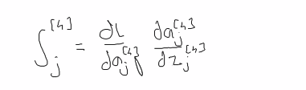
Chain rule se daj[4] k denominatior me dZj[4]
Iska derivative esa aayega
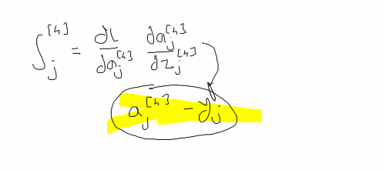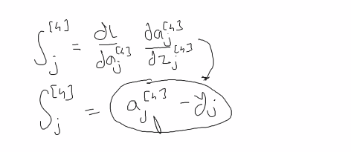
Kese aayega ye dekhege tb , code ka infra bn jaye phir ye proof krege.
Ab aj[4] kis se represent kiya jaa skta he, ans: isko hypothesis function H theta x j se bhi represent kiya ja skta he.
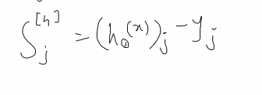
To finally delta4 ka har node ek vector hoga.
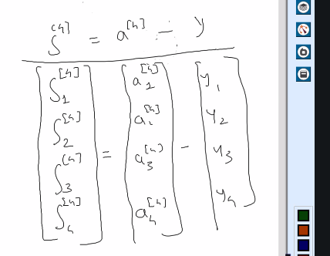

So we computed delta term for output layer
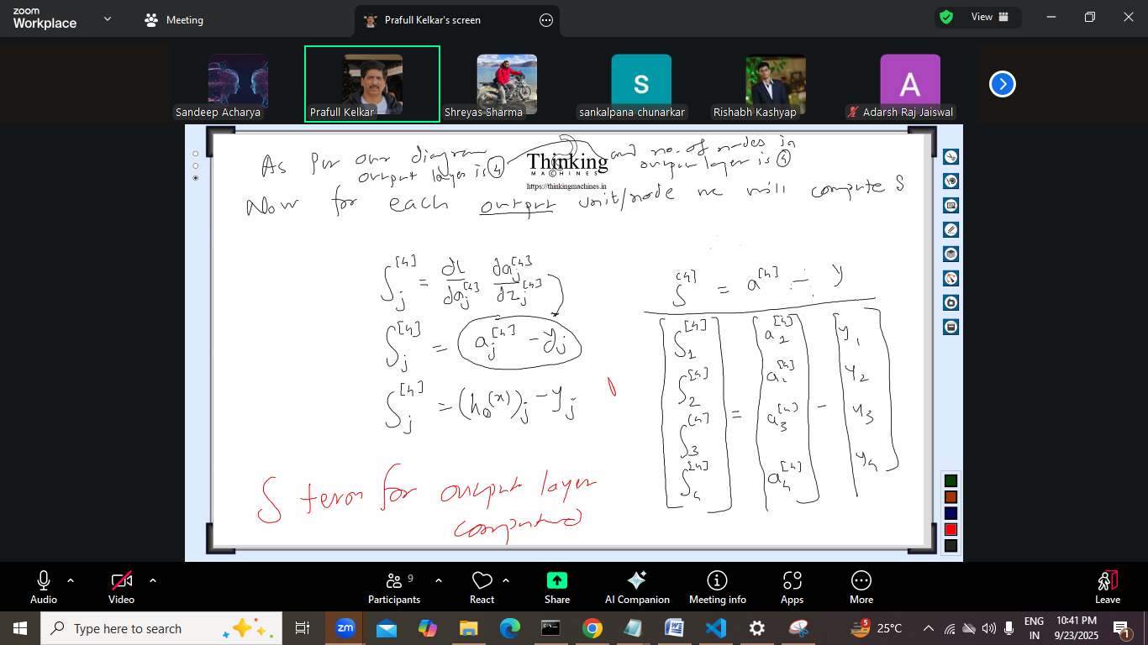
Isko mse se compare nahi krna he , yaha pr squere nahi aayega.
Ab delta 3 compute krna he: isko compute krne k liye bhi derivative ki baat aayegi.
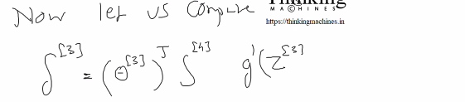
Is se kya produce hoga?
Theta and delta 4 se vector aayega * g dash se vector aayega
Uska multiplication element by element hoga
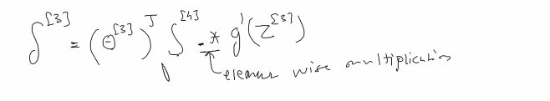
G dash Z 3 can be written as:
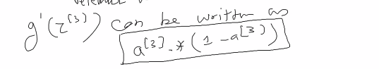

Ab delta 2 compute krne ki baat:
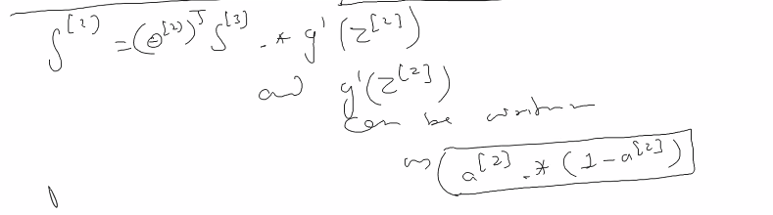
And delta 1 does not exist.
Board pr jo likha us se programming ho jayegi
But programming se board pr likha vo nahi ho payega.
2 chize pending he: ki ye derivatives kese aaye

Finally humko kya chahiye ye sb mathaphodi kr k:
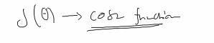
To finally
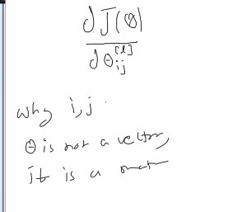
Ye theta k sath ij kyu aaya kyuki is baar theta is not a vector theta is a matrix in this case.
Finally it come down to this:
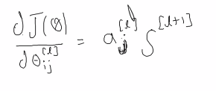
Ye video research paper pd k baar baar kr k dekha tb aaya
Still regularization is missing.
Above is for one traning example ,
Below is for many training example:
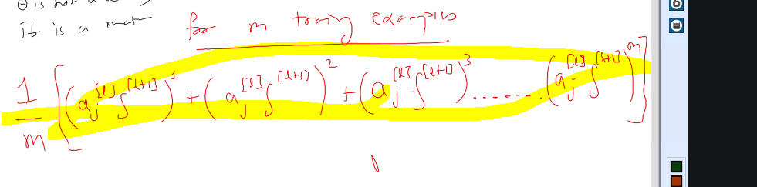
Ye sb yaad na ho to copy samne rkhna
Suppose hum phla training example lege , aage jayege, and delta 4 compute hoga. And delta 4 fresh ready hoga and uske bhrose delta 3 and 3 k bharose delta 2
Ye jisme accumulate krege usko 0 se initialize krege
Next training example me jo aayega usko isme sum krege. And so on till m
And finally m se divide krege
Phir theta updation ki baat aayegi.

Programming k hisab se delta vectors bnane pdege.
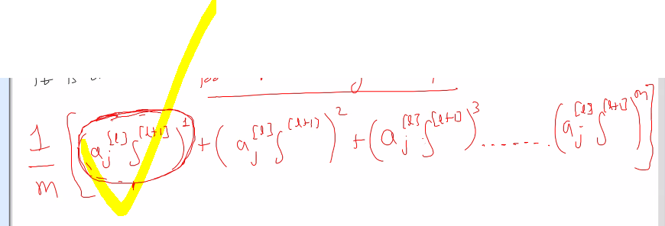
Isko accumulate krna he.

Jese fomula dikha he ese ye dikhna chahiye , isko bina dekr bol k
Delta 4 compute kiya a4-y
Delta 3 k liye theta 3 ko delta 4 se multiply and g dah se jo bnega us se element wise multiplication
A3*(1-A3)
Finally vo AJ and har training example ka accumulate
Layer k bich accumulate krne k liye delta ka symbol liya and hare k ka calculate ke liye uppercase delta

Next session pseudo code likhege.

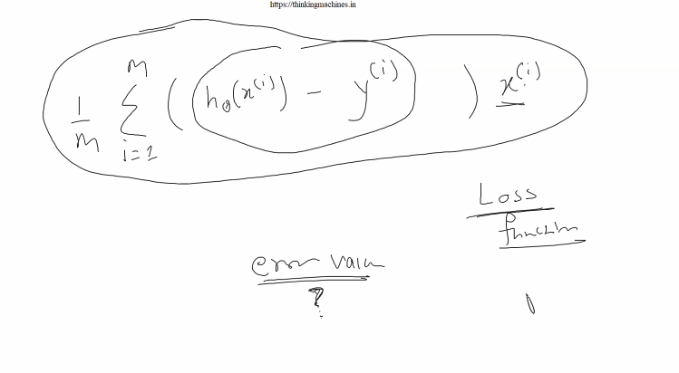
Loss function se job hi nikala jaata he us se error value wali baat aati he
And loss function k derivative se job hi nikala jaata he usko update rule bolte he and use se theta ko update krne wali baat aati he.

